Leadership Case Studies

Review the major characteristics of the 4 social styles below. Then, consider how different personality styles might approach each of the following scenarios.
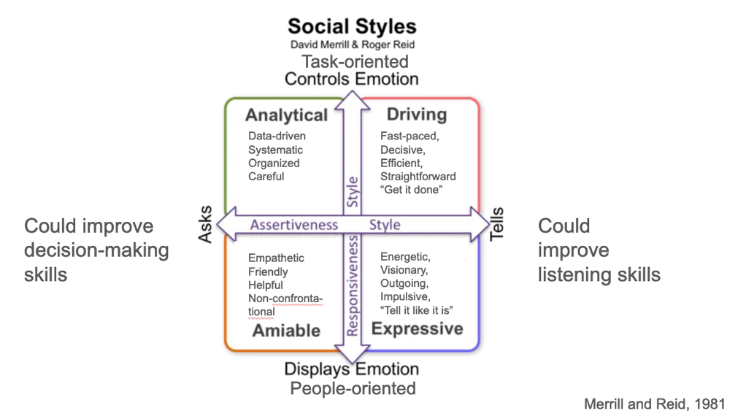

Case Study 1: A FT research assistant has been working sporadic hours and not meeting full-time requirements. This behavior is wasting resources and negatively affecting other group members, who have to deal with the assistant’s unfinished tasks before they can accomplish their own tasks.

What is the likely response of a Driver vs Expressive vs Amiable vs Analytical?
Driver:
Expressive:
Amiable:
Analytical:

How might a leader with one preferred style leverage the strengths and preferences of another style to resolve the situation effectively?

Case Study 2: A second-year grad student has been working under the supervision of a senior postdoc. The student has become less productive in general, and has been complaining to other group members that the postdoc is taking credit for the student’s ideas. Some group members now seem to be taking sides, and tension is disrupting working relationships.

What is the likely response of a Driver vs Expressive vs Amiable vs Analytical?
Driver:
Expressive:
Amiable:
Analytical:

How might a leader with one preferred style leverage the strengths and preferences of another style to resolve the situation effectively?

